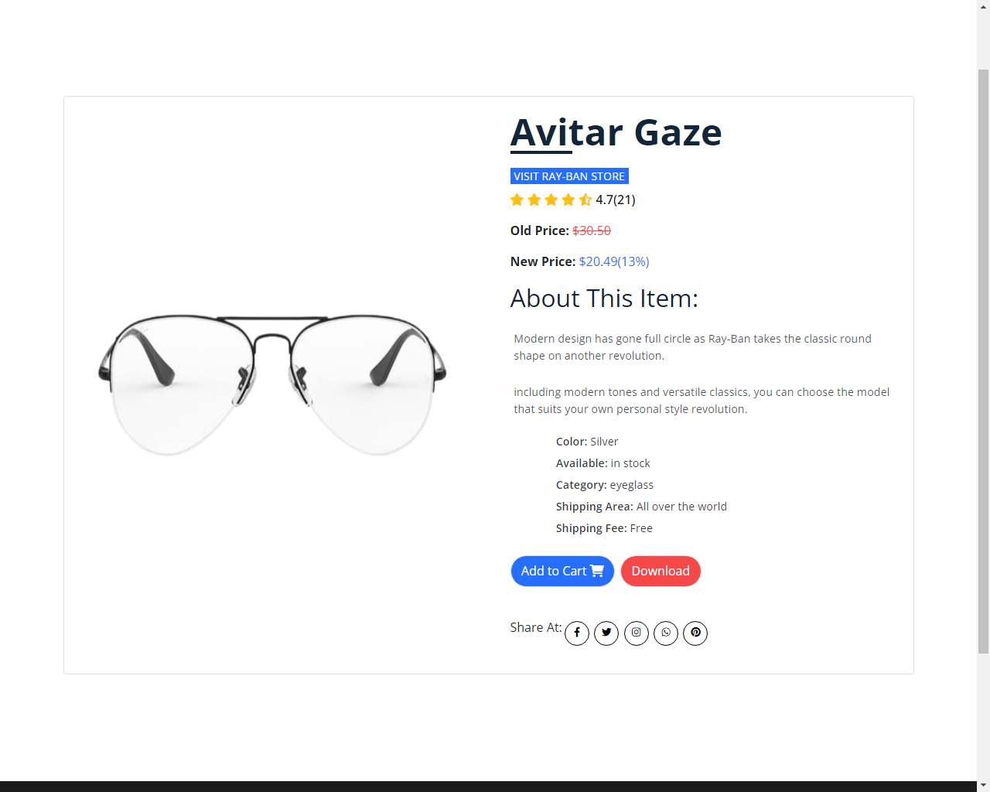

Less is more with a semi-rimmed style that brings a new level of sophistication to the iconic Aviator.  
With all the daring of the original, the refined optical frame comes in sleek metal colorways with the option for eye-catching black or Havana enamel combinations in two different sizes. Get your pair with prescription lenses for a subtle accessory that makes a big statement.

## PRODUCT DETAILS